Writer’s Notebook Graffiti Page

Directions: Take a minute to think of everything you can that tells about yourself. Think about the basics like eye color and hair color but also think about things like what you like, what you don't like, places you like to go, things you like to do, and so on.
Take that information and create a "graffiti wall" about yourself on the first page of your writer’s notebook. Make it neat, and include labels! This page will tell about you as a person, and also as a writer!

Use the picture as an example, but try to make this your own.
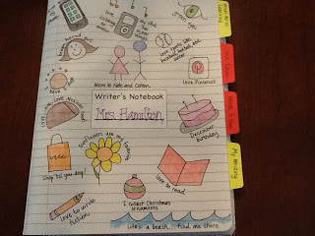
Have fun!

